**COMSATS University Islamabad, Lahore** **Campus**

**Assignment-III – Spring 2024**

|  |  |  |  |  |  |  |  |  |  |
| --- | --- | --- | --- | --- | --- | --- | --- | --- | --- |
| Course Title: | Computer Networks | | | | Course Code: | CSC340 | | Credit Hours: | 4(3,1) |
| Course Instructor/s: | Dr Tariq Umer | | | | Programme Name: | BS Software Engineering | | | |
| Semester: | 5th | Batch: | FA22-BSE | Section: | A | Date: | 12-05-24 | | |
| **Dead line** |  | | | | **Maximum Marks:** | | **20** | | |

**Question:**

**CLO-1 Summarize the fundamental concepts of computer networks.**

Q1- a- Apply VLSM according to the given requirement by using class C IP address.

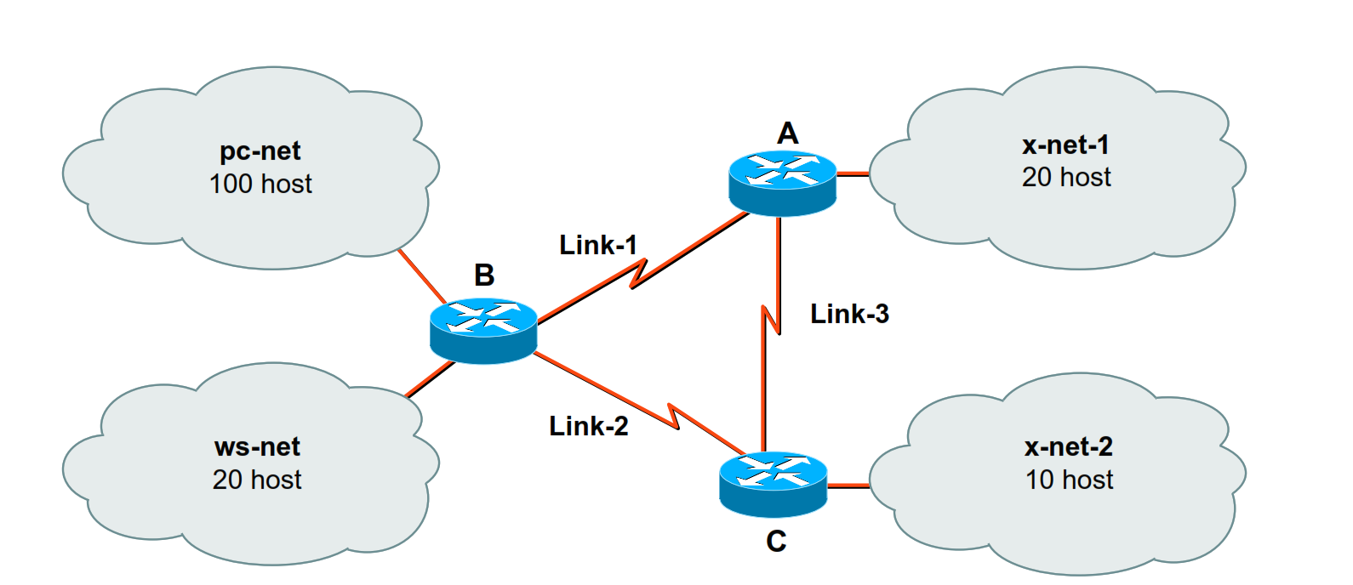

Q1-B

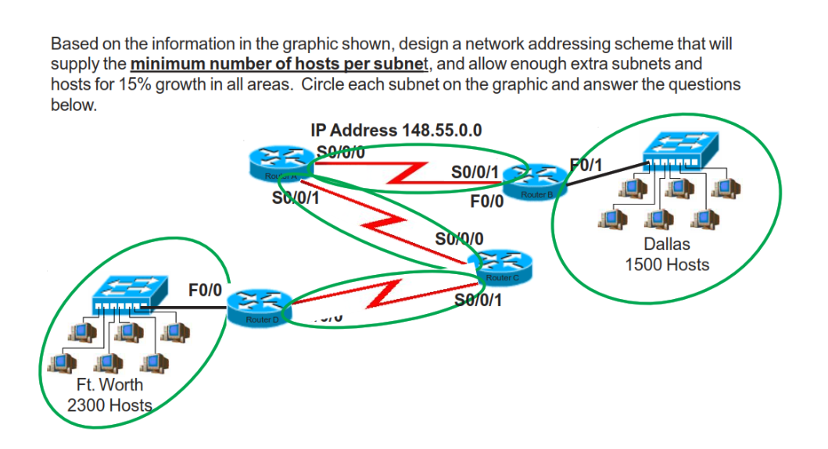

c- Given the following IP address 192.168.121.46 a subnet mask of

255.255.255.240/28 determine the following:

1- Class of IP address

2. Default subnet mask

3. Network Address

4. Subnet ID

5. Broadcast address of the subnet.

d- Given the following IP address 172.16.189.5 a subnet mask of

255.255.254.0/22 determine the following:

Network Bits= Subnetwork Bits= Host Bits=

1.Class of the IP

2. Default subnet mask

3. Network Address

4. Subnet ID

5. Broadcast address of the subnet.